Portfolio 2

**Student Name: Ashish Thomas Varghese**

**Student ID: 8797297**

**SYST8150 – Hybrid and Converged Solutions**

**Umair Hashmi**

**Due Date: March 08, 2024**

# Table of Contents

Portfolio 2 3

Lab 5: Creating hybrid network and routes between two cloud 3

Description 3

Preparation 3

Observations 3

Screenshots 3

Reflection 16

References 17

# Portfolio 2

## **Lab 5: Creating hybrid network and routes between two cloud**

## Description

This lab consists of the following tasks:

* Setting up Virtual Private Cloud networks in two different cloud vendors
* Setup a private routing between the VPC
* Configuration of site-to-site virtual private network (VPN) between the two networks.
* One end of the network should be routable to the internet
* Suggestions to secure EC2, storage and database.

## Preparation

This lab requires accounts in two different vendors, Here I opted for Amazon Web Services and Google Cloud Platform.

## Observations

The article provided in the document wasn’t enough for completing this lab, I went to external sites to refer more about the setup. The article mentioned of selecting classic VPN for the GCP side setup, I received the error,

“Invalid value for field 'resource.peerIp': '34.226.252.151'. Cannot create a classic VPN tunnel with dynamic routing. Peer IP is outside of Google. Peer IP has to be used by a Compute Engine VM. Other Classic VPN usages are deprecated.”

As the usage of classic VPN for dynamic routing is deprecated. I had to find my ways to make this work.

## Screenshots

Before beginning the configuration of VPCs, I started reserving a static VPN, which is linked to the VPC later, thus the VPC has a unique external IP range that prevents modification of IP Configuration.

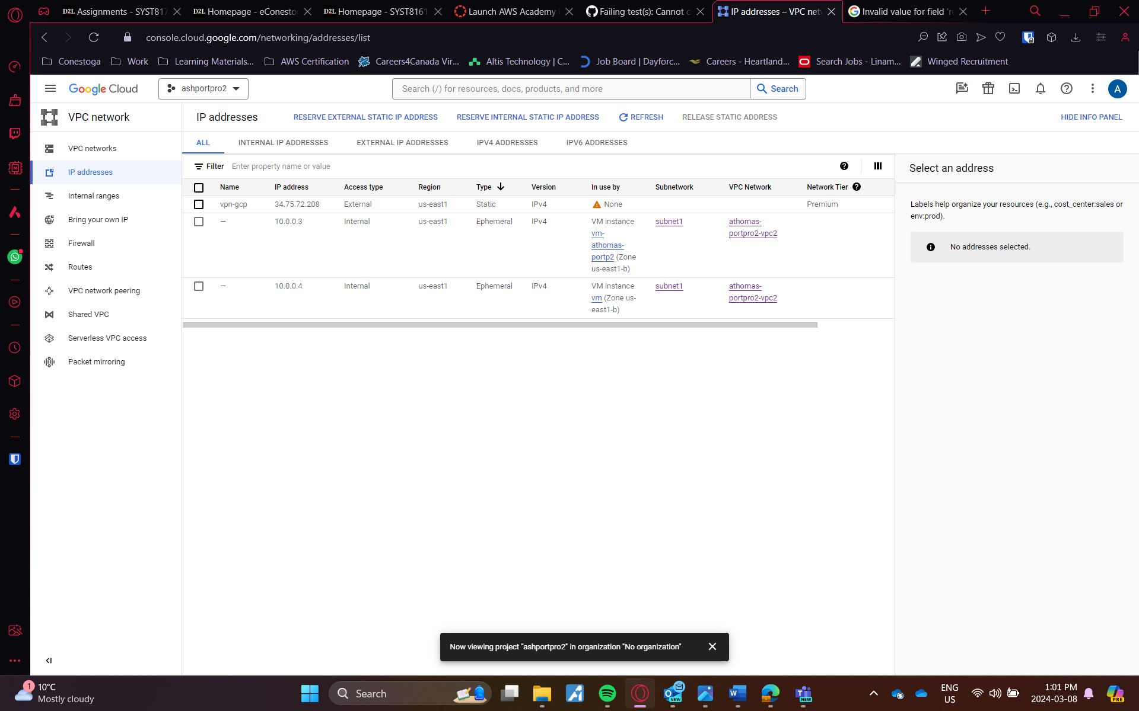Fig 1: External IP reservation

Next, I created two VPC in both AWS and GCP. For AWS, I went with 192.168.0.0/16 range and GCP10.0.0.0/16.

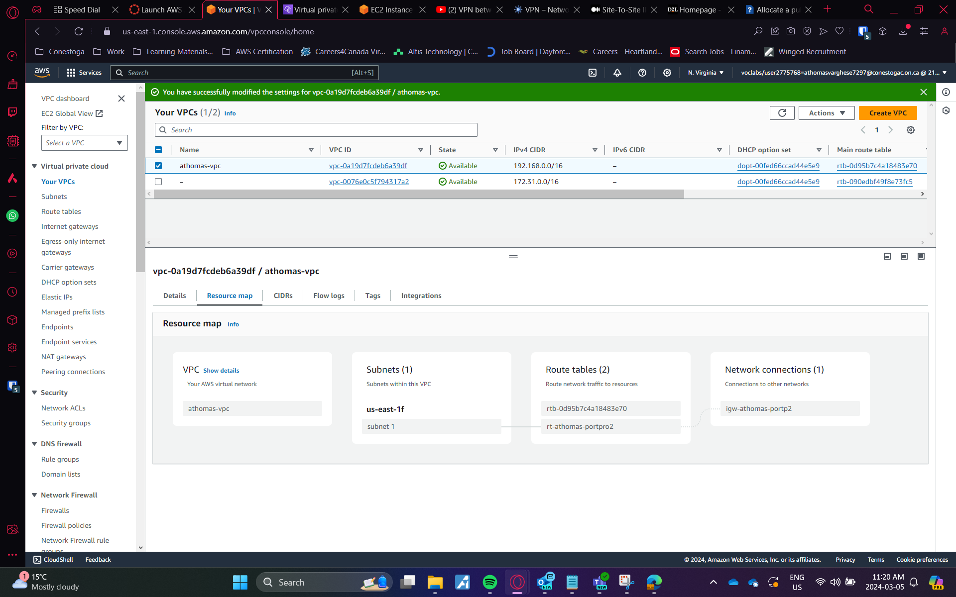Fig 2: VPC creation in AWS

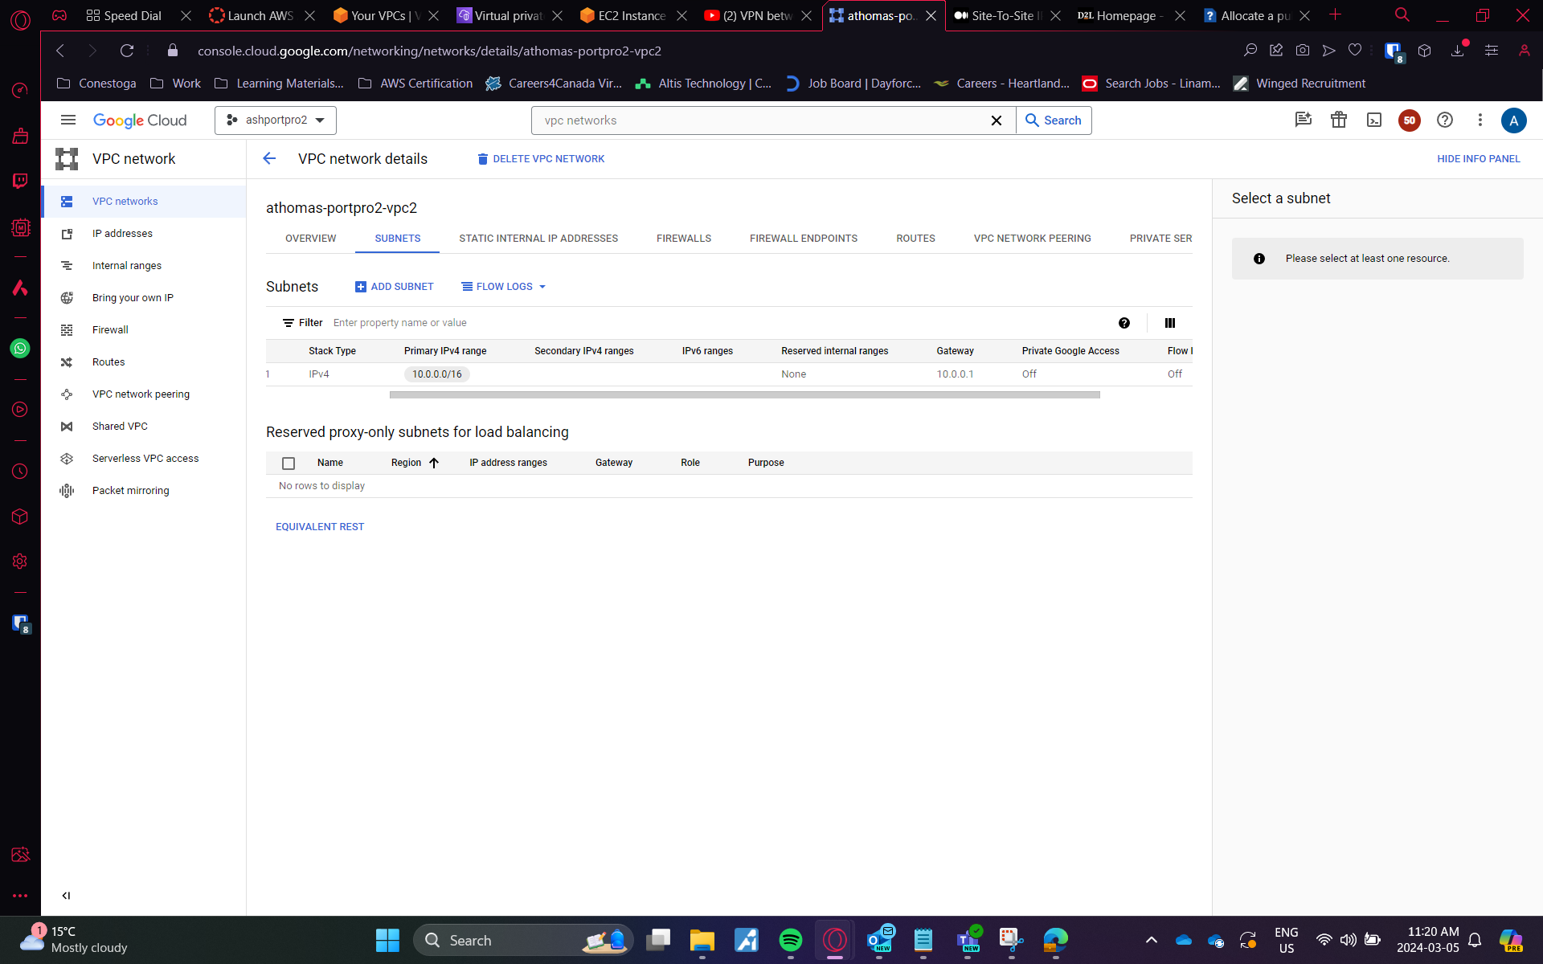Fig 3: VPC creation in GCP

I started creating cloud router in GCP, which is used to advertise the networks using BGP Peers. For all the setup, I used to us-east 1 region. The ASN (autonomous system number) I configured is 65533 which is different for AWS setup.

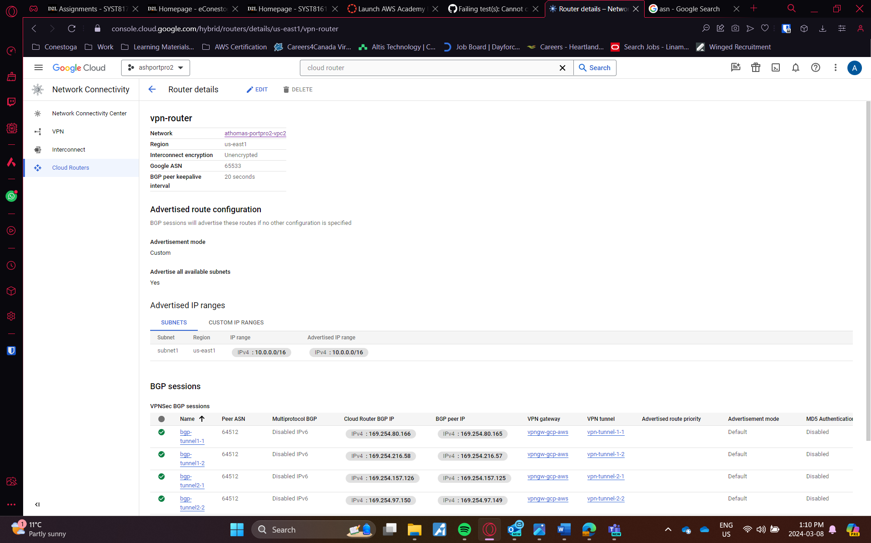Fig 4: Creation of cloud router

After this went to VPN setting to create a gateway in GCP. I went with High Availability VPN. Created the gateway and got the IP for both of the interfaces.   
  
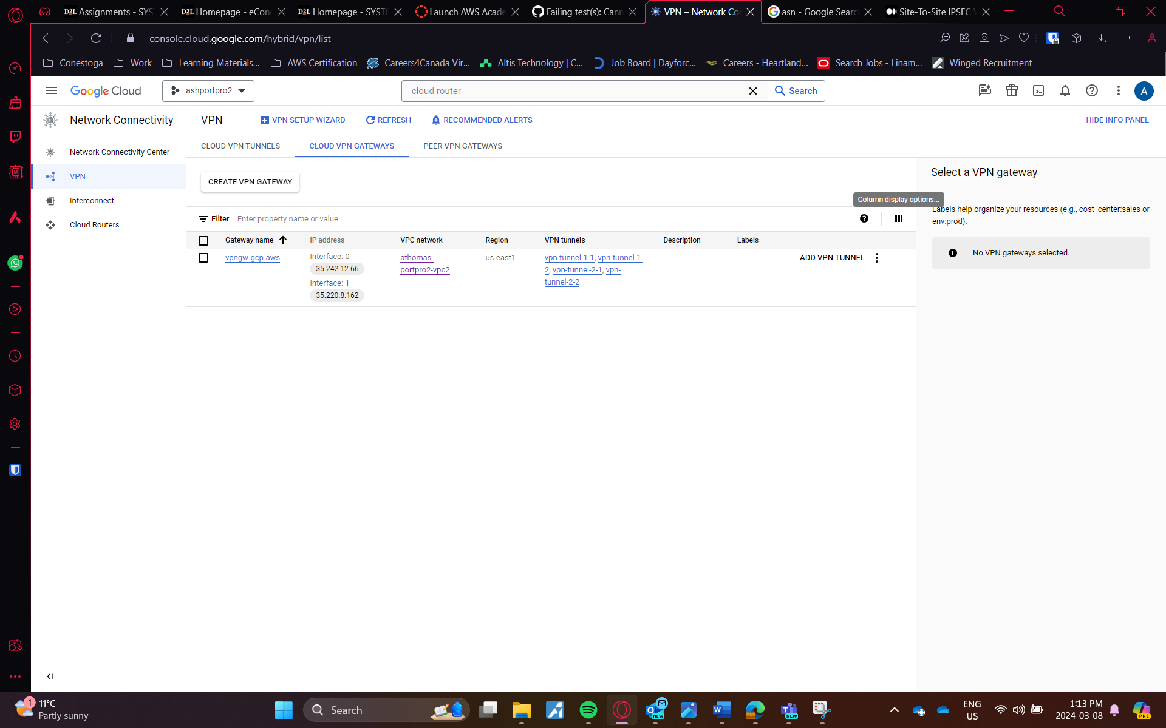 Fig 5: Configuration of Cloud VPN Gateways in GCP

Next step was to configure the AWS side. I started with creating two customer gateway, here setting up with the same ASN as GCP is important, as the connection is made through BGP protocol. The two interface IP addresses is given for each customer gateway for redudancy.

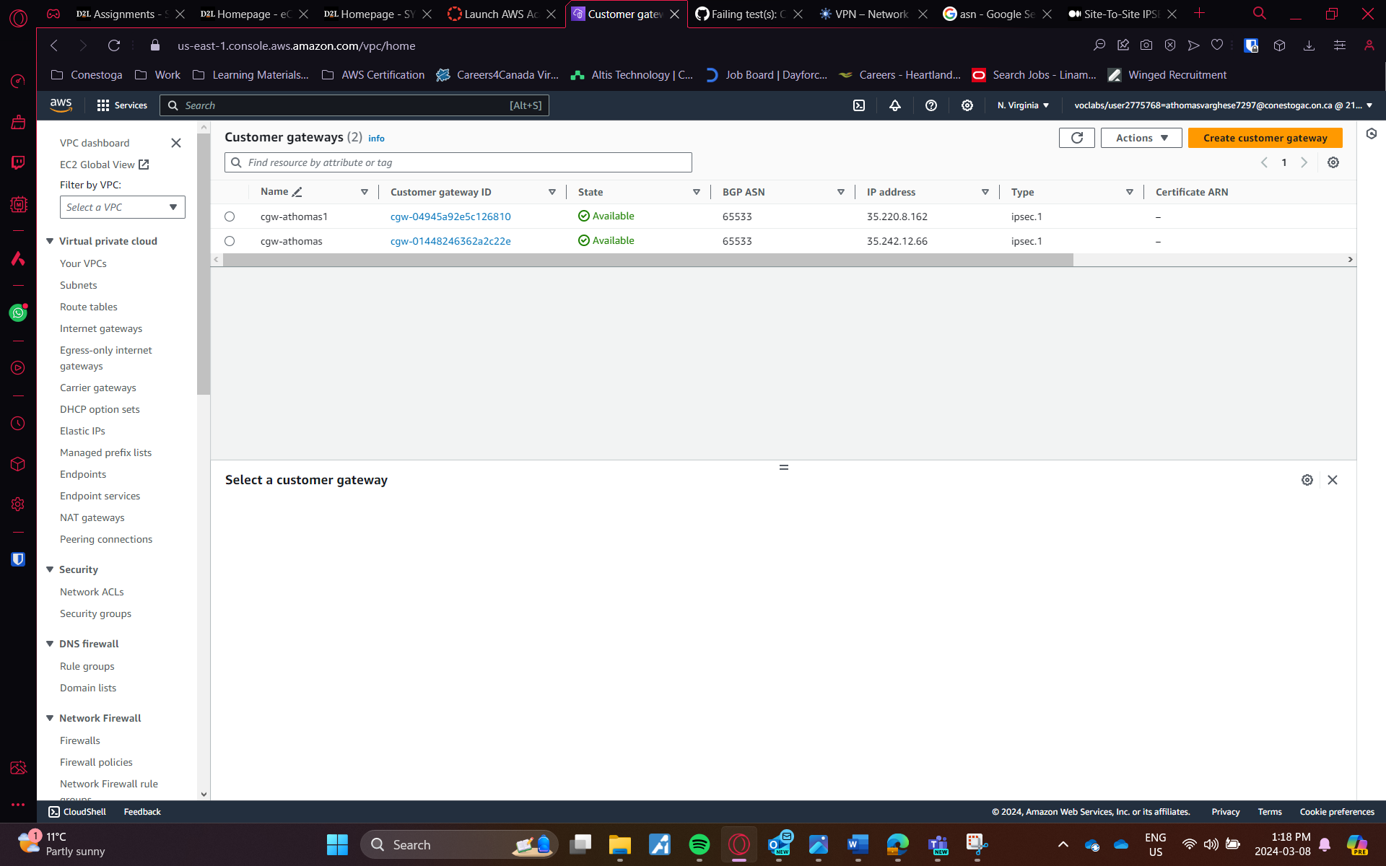Fig 6: Customer Gateways in AWS

Additionally we want to create a virtual private gateway for tunnelling the traffic to the end point. We have to attach it to the VPC.

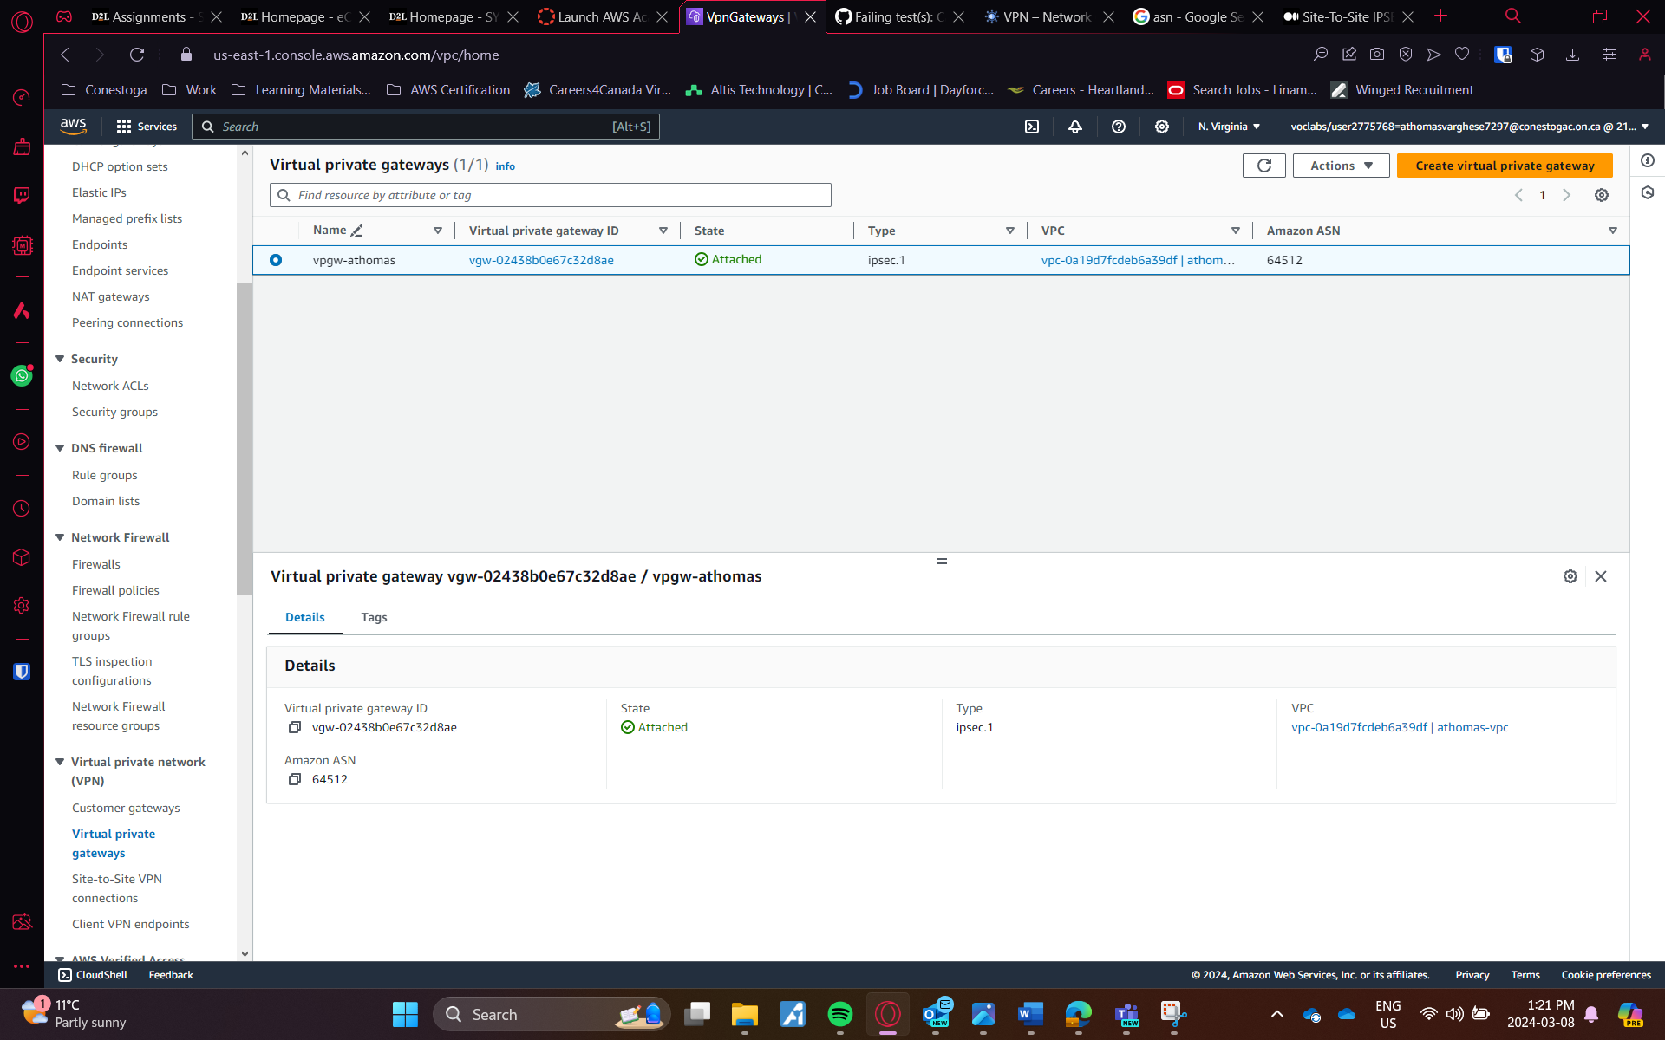Fig 7: Virtual Private Gateway in AWS

After this we have to make sure that the subnet is associated and enabled for route propagtion.

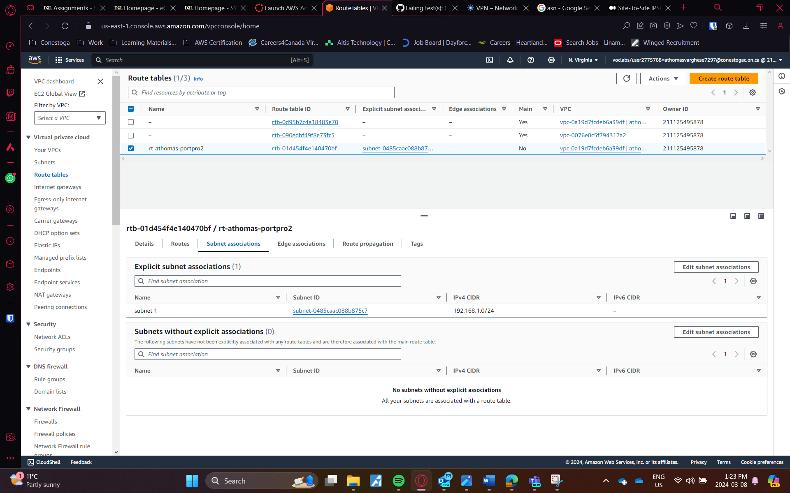Fig 8: Subnet Associations

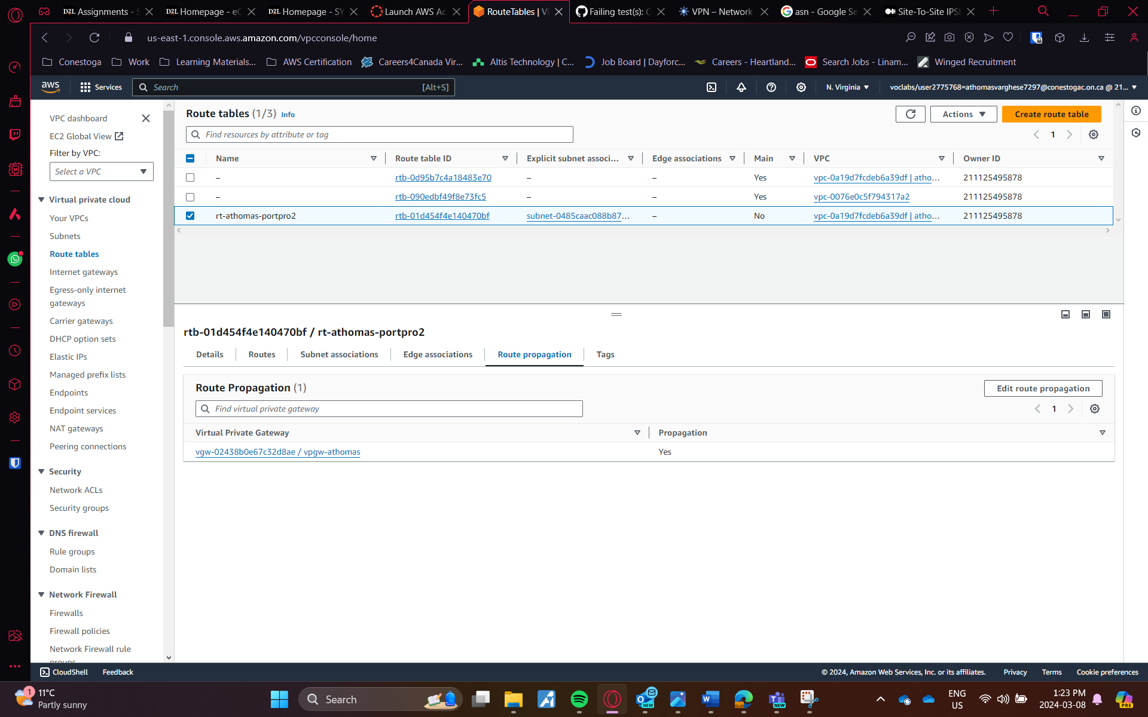Fig 9: Route Propagation Enabled

Site-to-site VPN is configured. Here we have two customer gateways, so we have to create two VPN connections, this way our VPN service is redundant, If one link fails, we have another VPN.

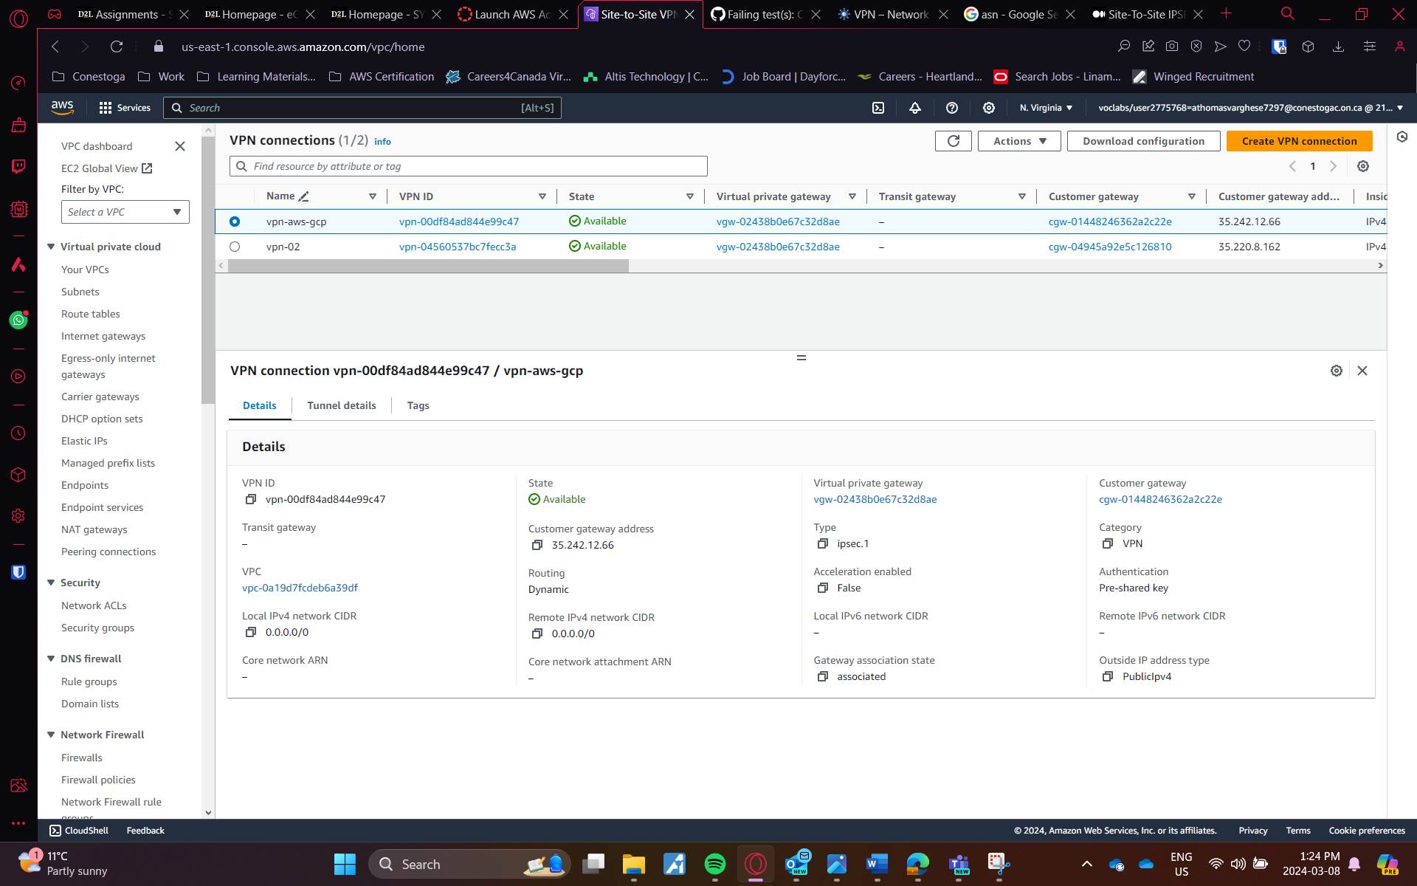Fig 10: VPN connections in AWS

The peer vpn gateway is created with the addresses mentioned in the tunnel details. The details are also found in the configuration files which can be downloaded from AWS after successfully creating the VPN connection.

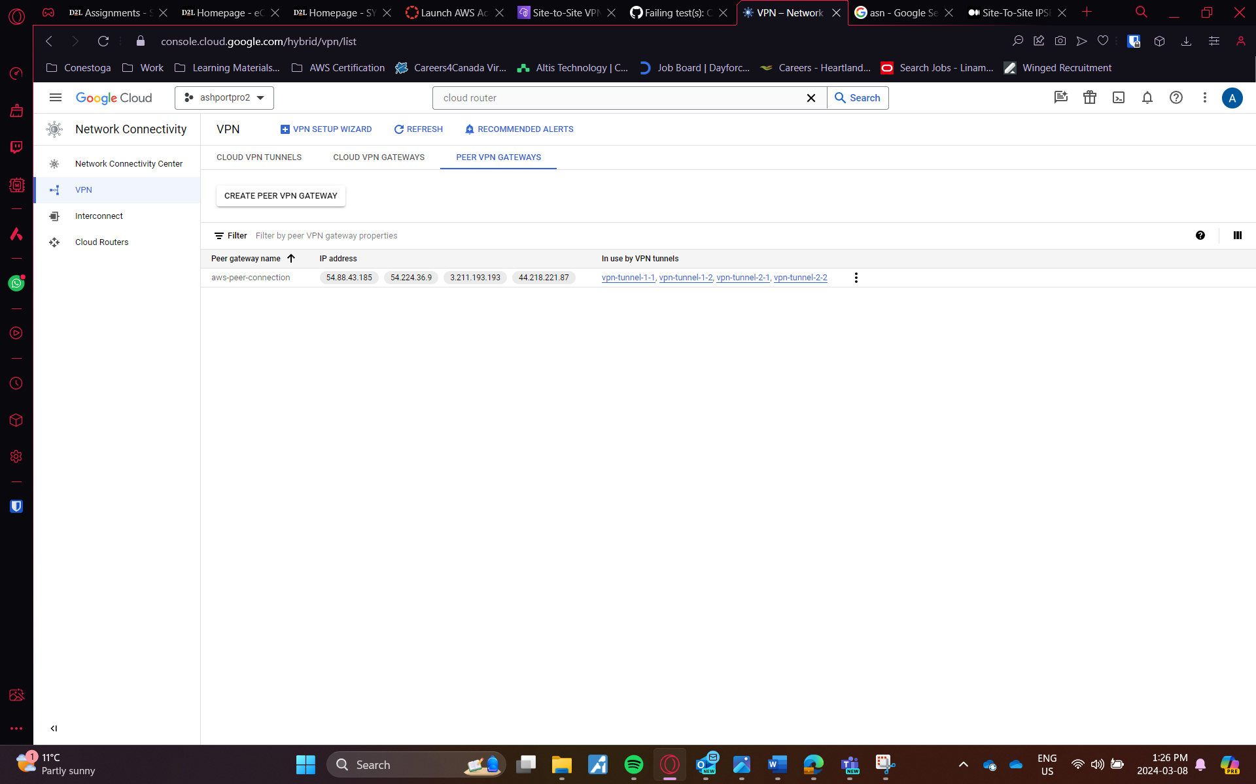Fig 11: Peer VPN gateway configuration

Next step is created the VPN tunnels in GCP, the necessary details needed to finish this is given in the configuration files. The BGP sessions are created in the same steps. After configuration of the BGP sessions, the VPN will do the handshakes and then the connection is established.

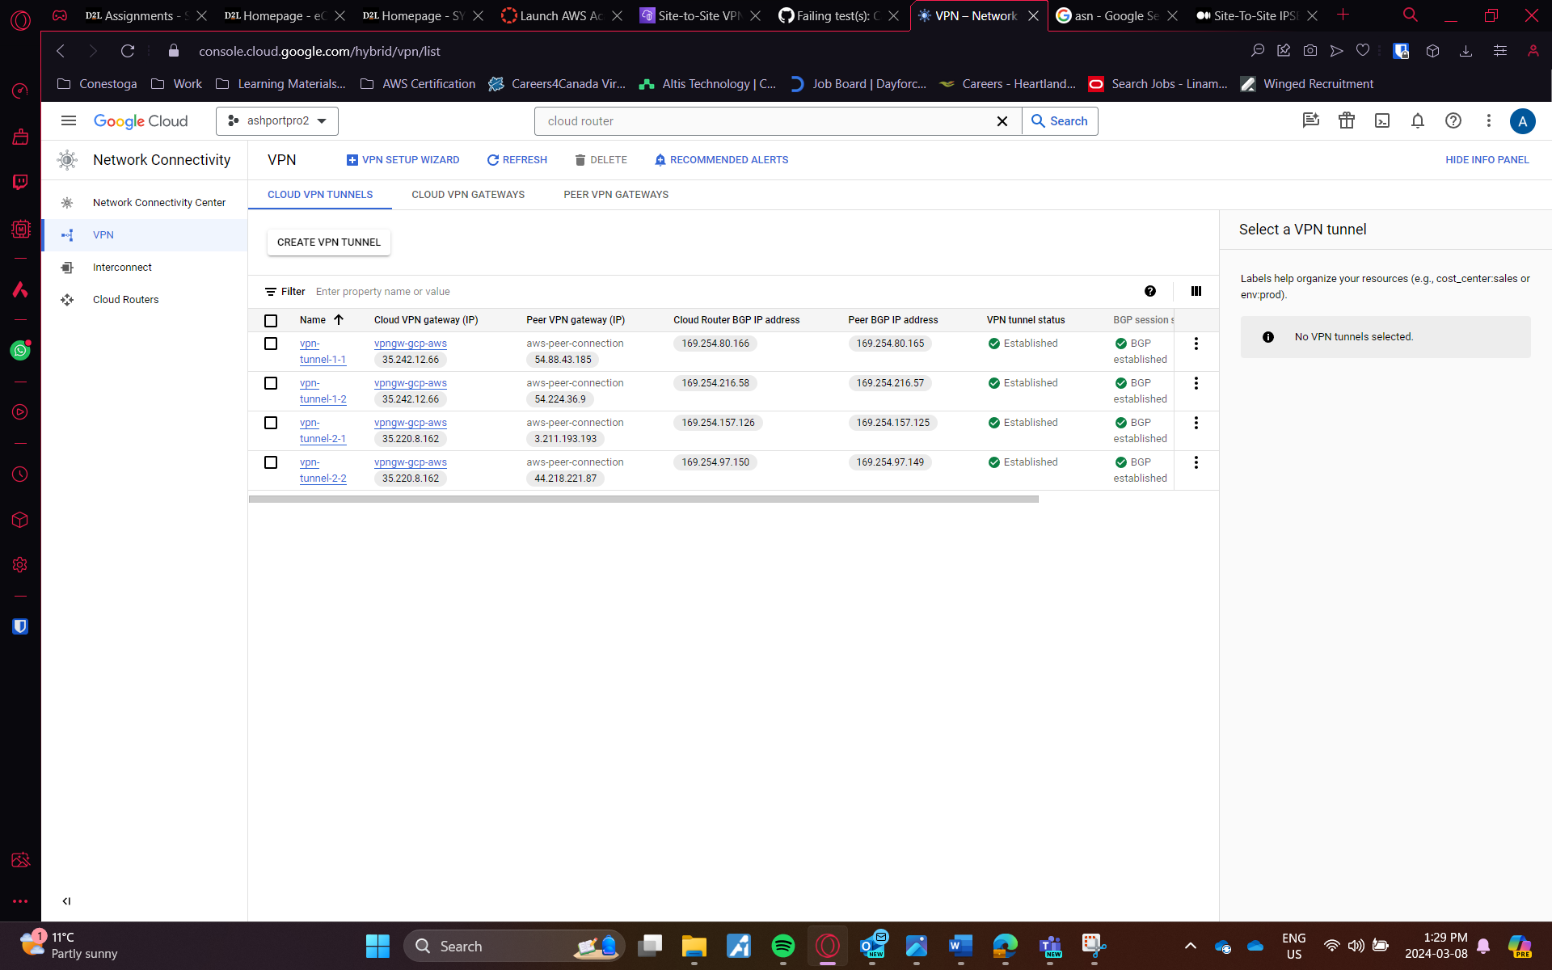Fig 12: Cloud Tunnels Up and running

On AWS side, we will get the status for the tunnel UP. It may take some time to update, for me it took 4-5 minutes for the status message.

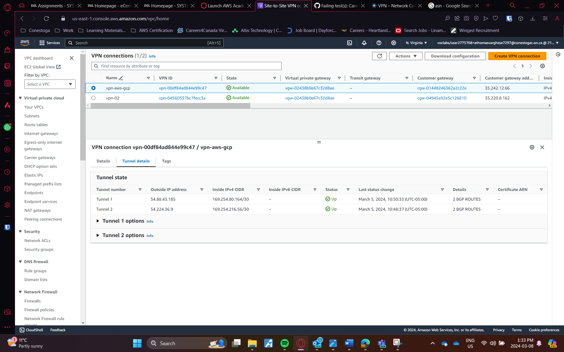Fig 13: VPN Tunnels UP in AWS

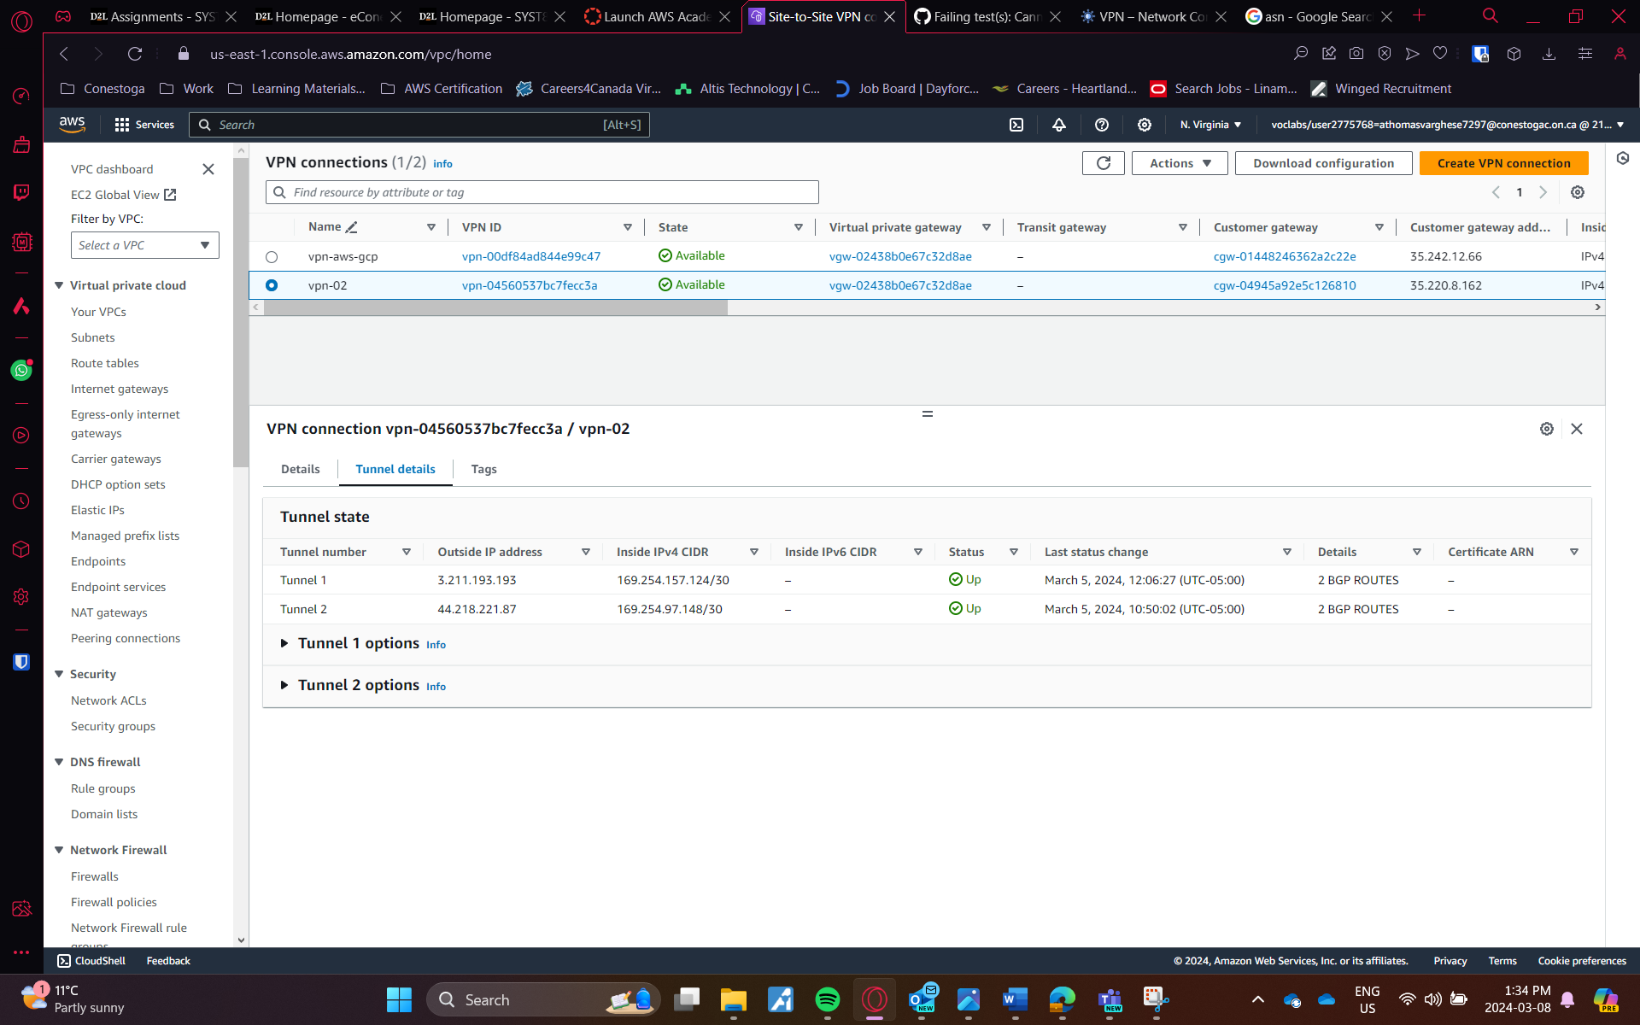 Fig 14: VPN Tunnels UP in AWS

After this I created instance on both sides with the VPC which I created. Make sure necessary rules are added into the firewall and security groups so that the both system can ping eachother.

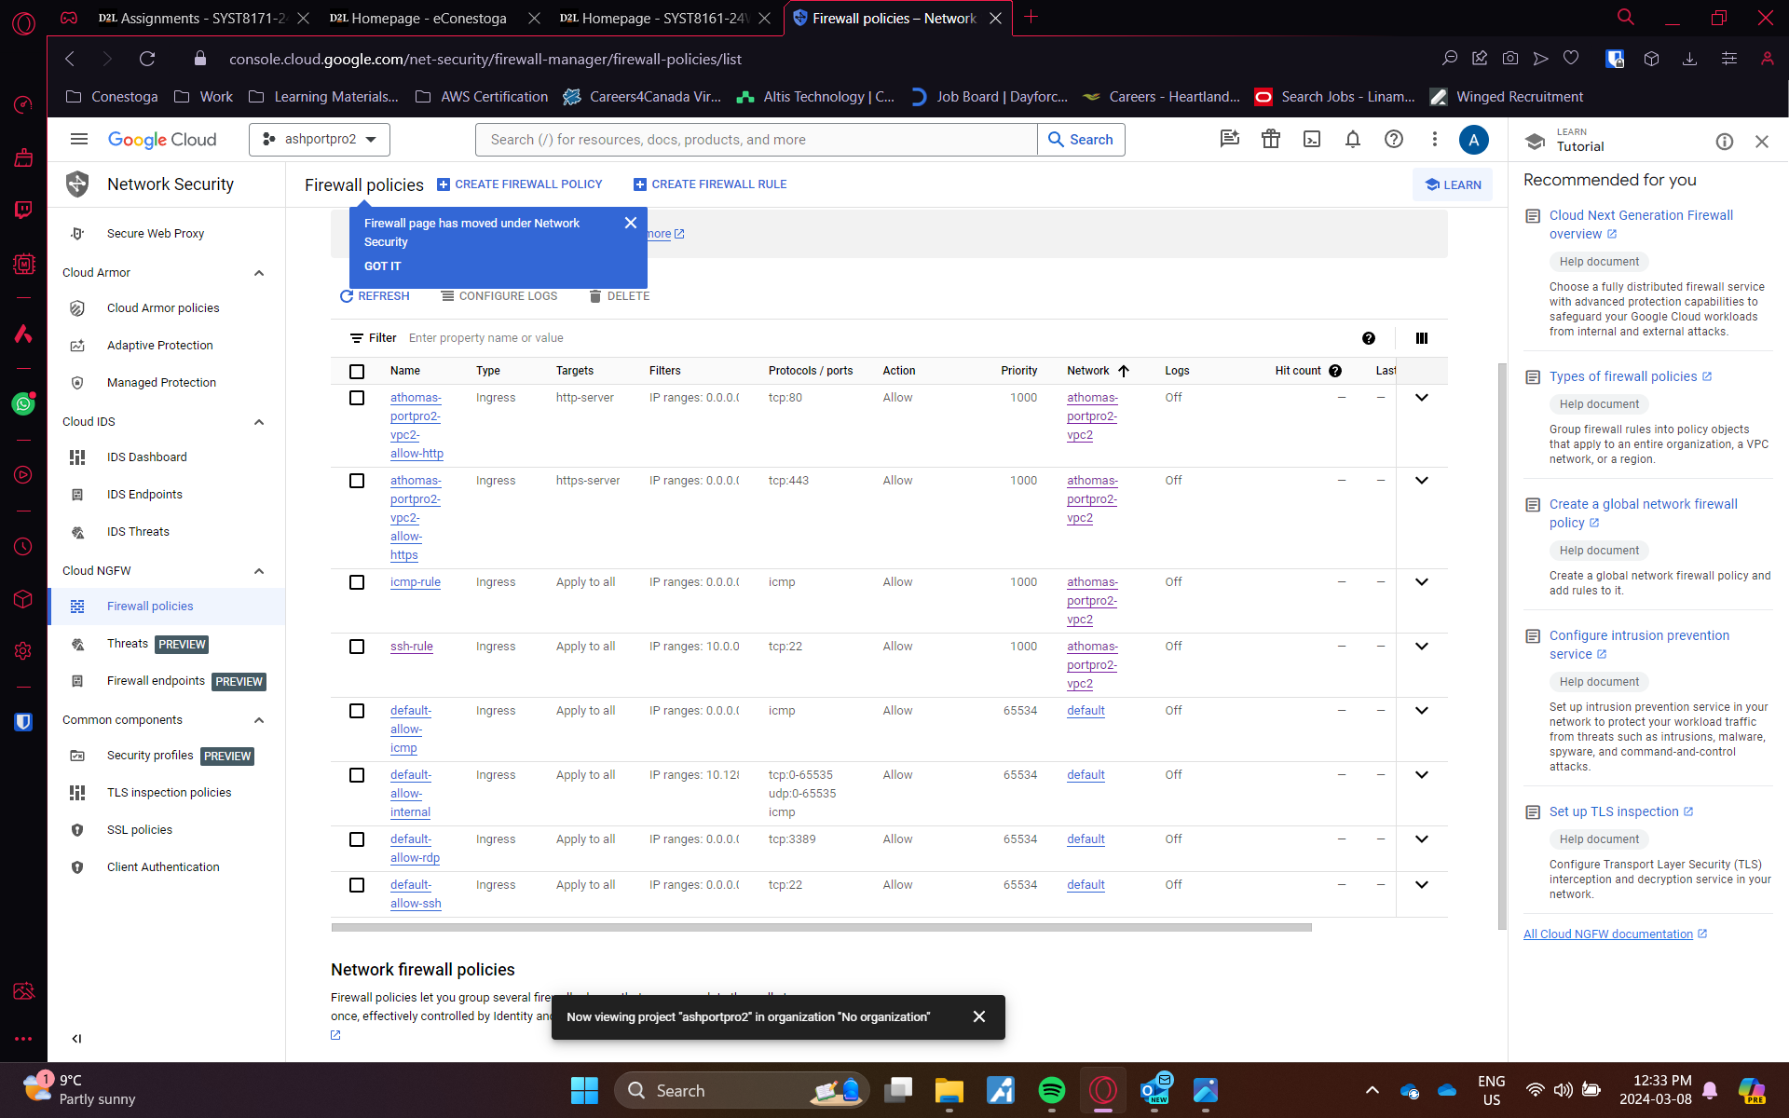Fig 15: Firewall rules in GCP

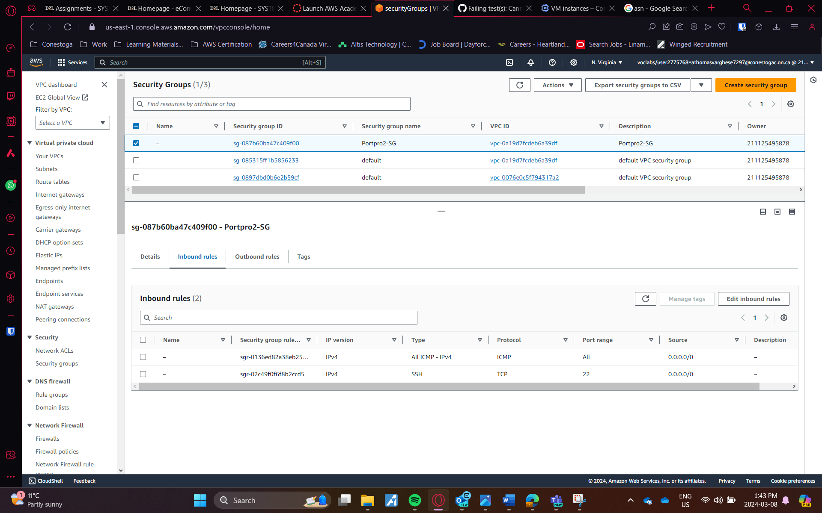Fig 16: Security Groups in AWS

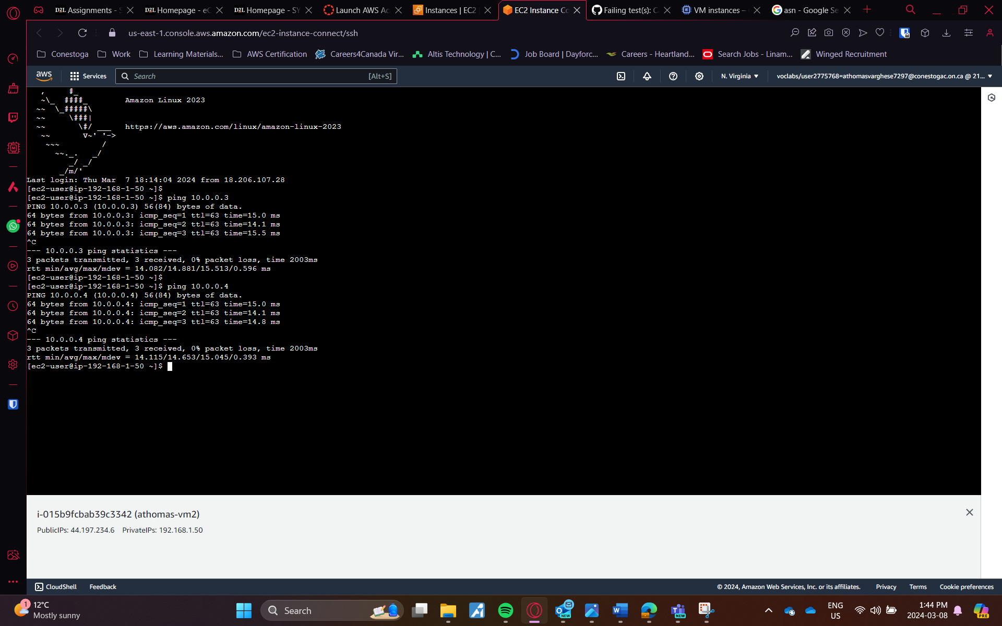Fig 17: Connectivity using ping command

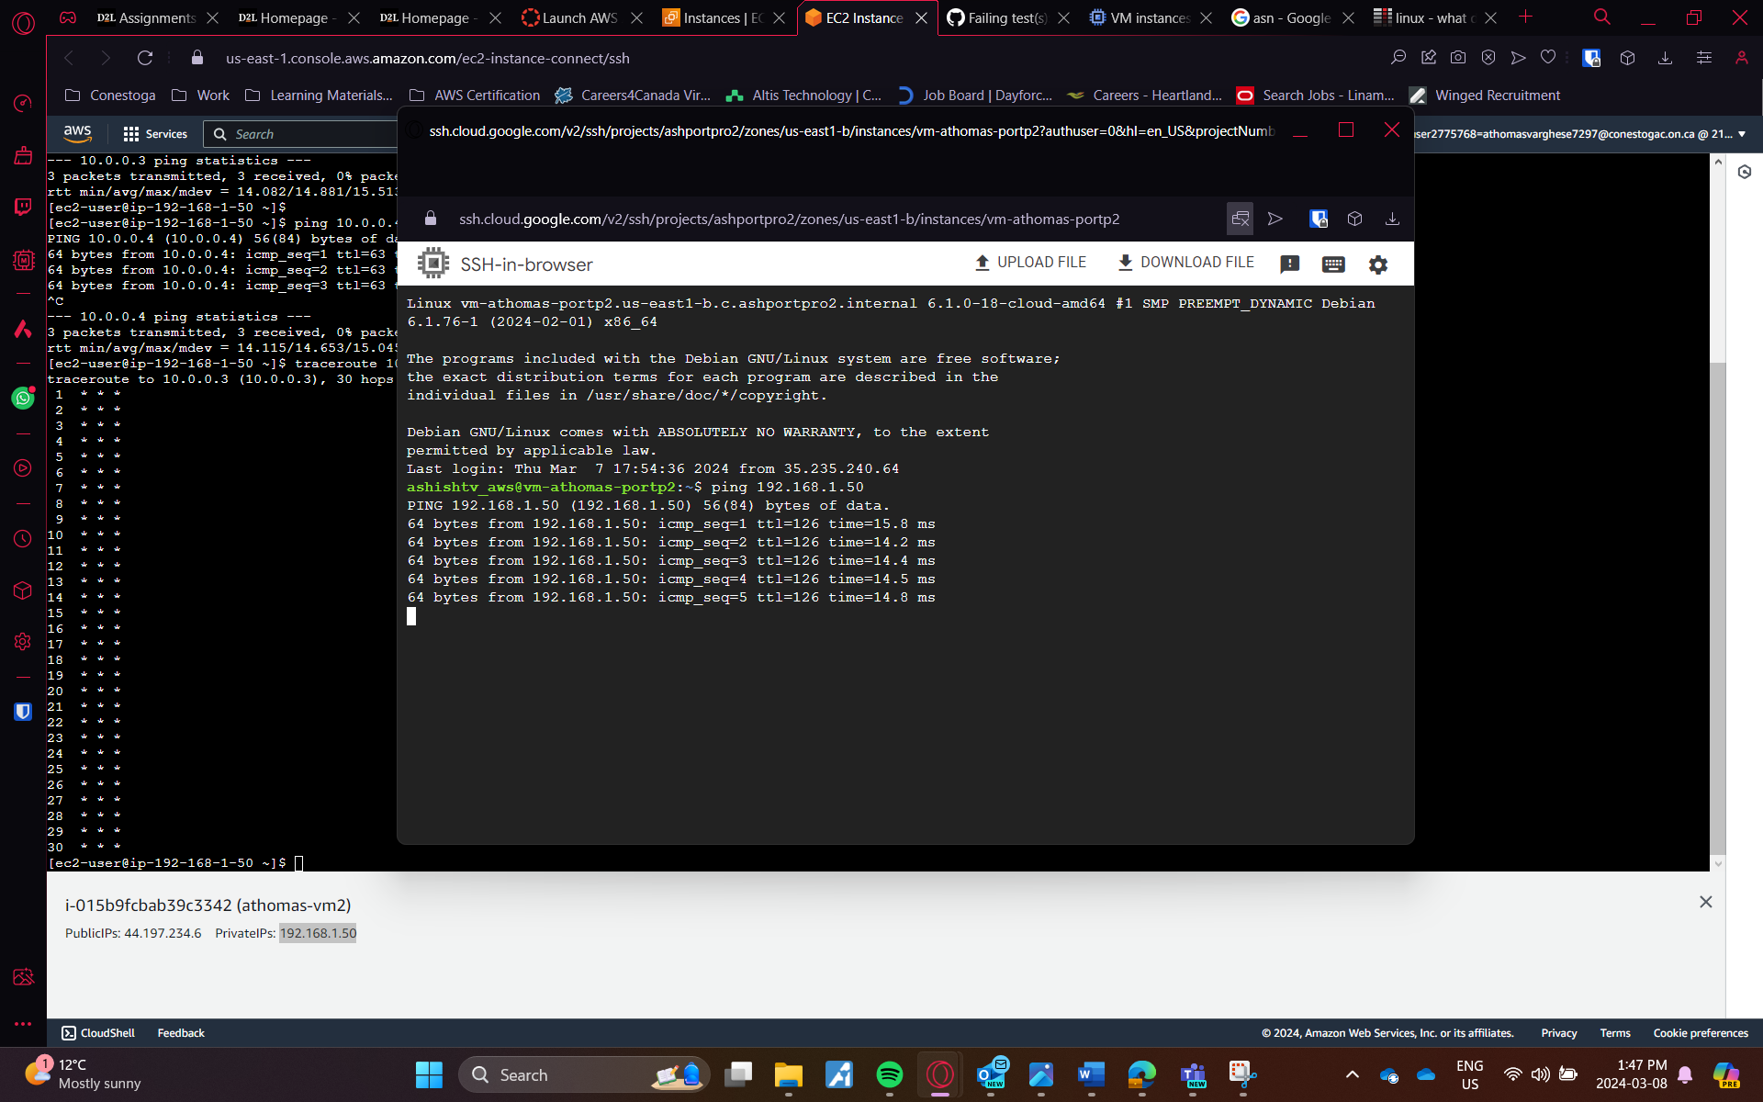Fig 18: Connectivity using ping command from GCP

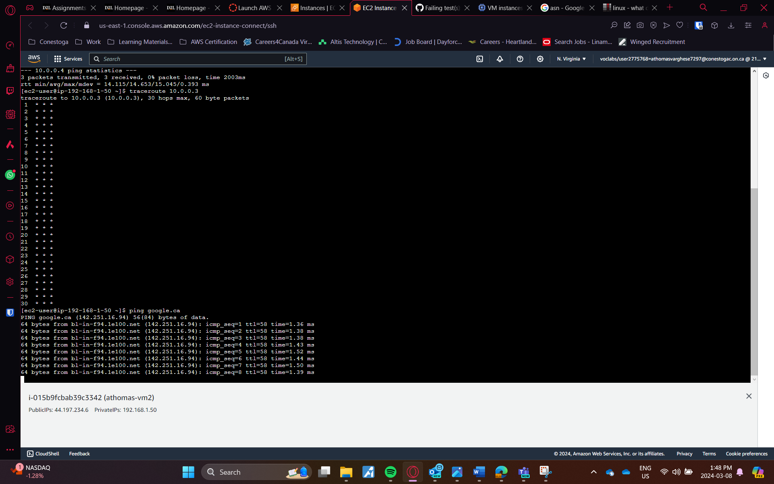Fig 19: Connectivity to internet using ping command

For Implementing Security measures within database. Create the database in VPC with 3 subnet in 3 availablility Zone with public access denied so unauthorized users cannot access the database. For accessing the RDS we can assign IAM roles which is the secure way of accessing the DB.

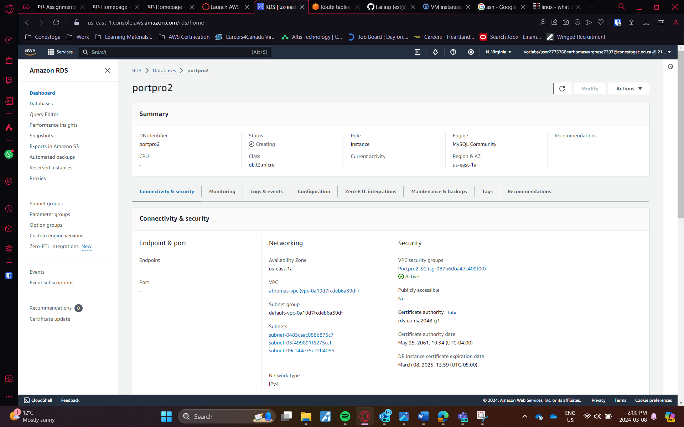Fig 20: Security in RDS Setup

For EC2, patching up the softwares is essential as vulnerablilities in any applications could lead to a breach in VM. Enforcement of firewall rules, close all the unused ports.

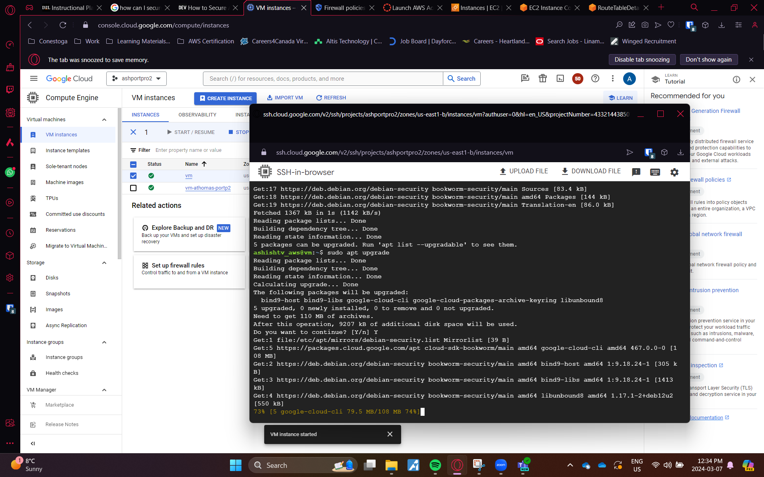Fig 21: updating the instance application

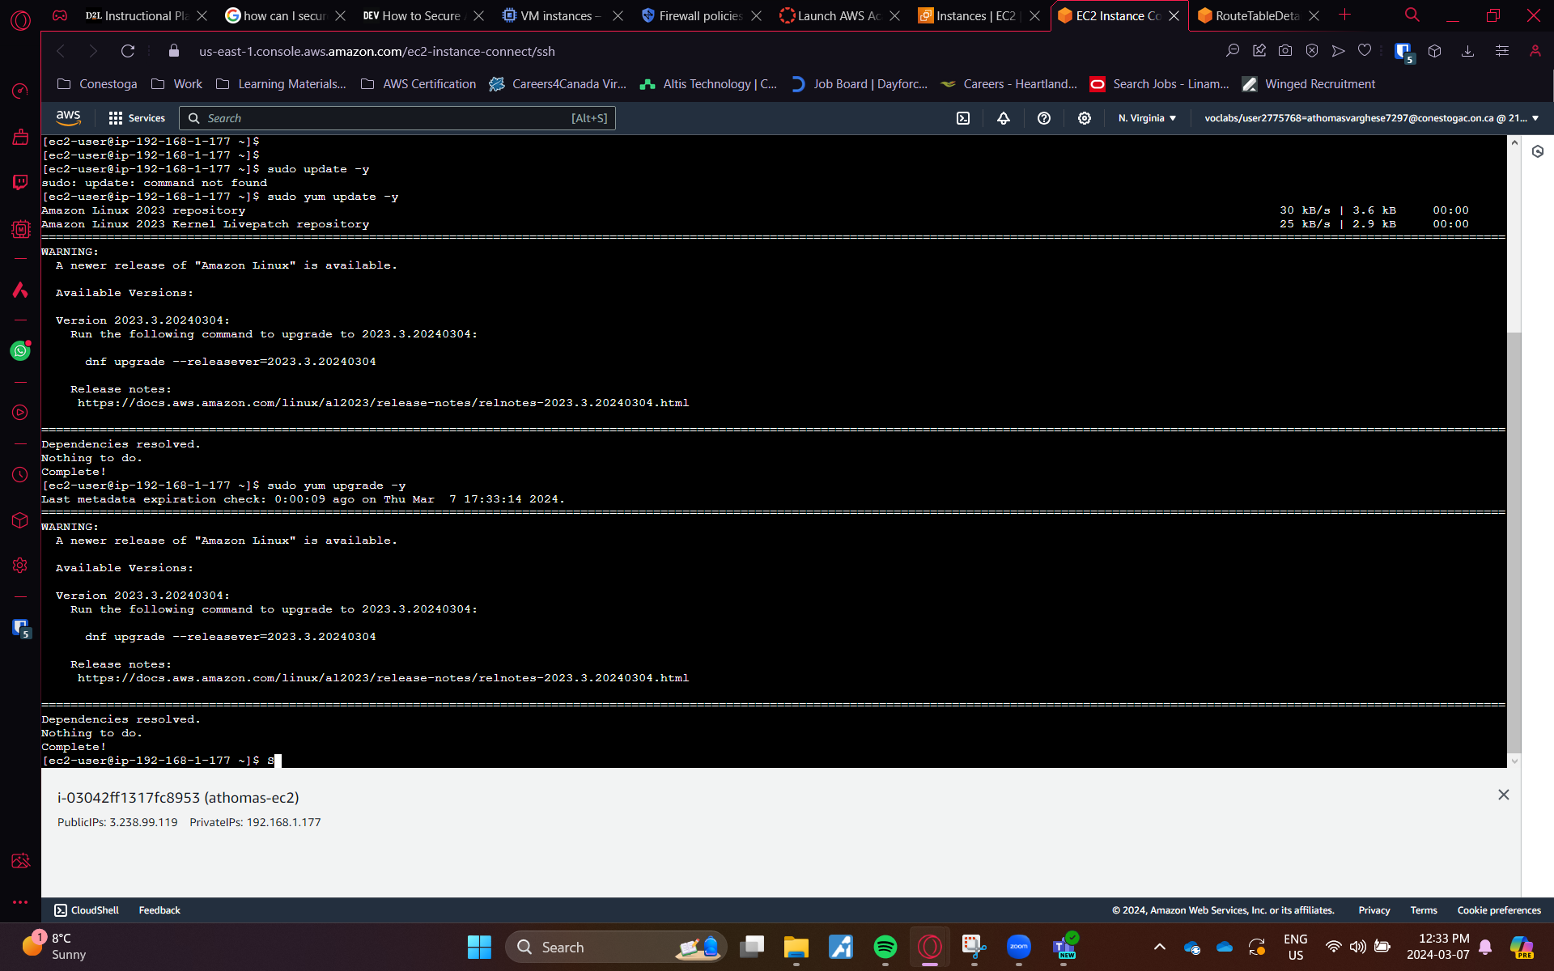Fig 22: updating the instance application

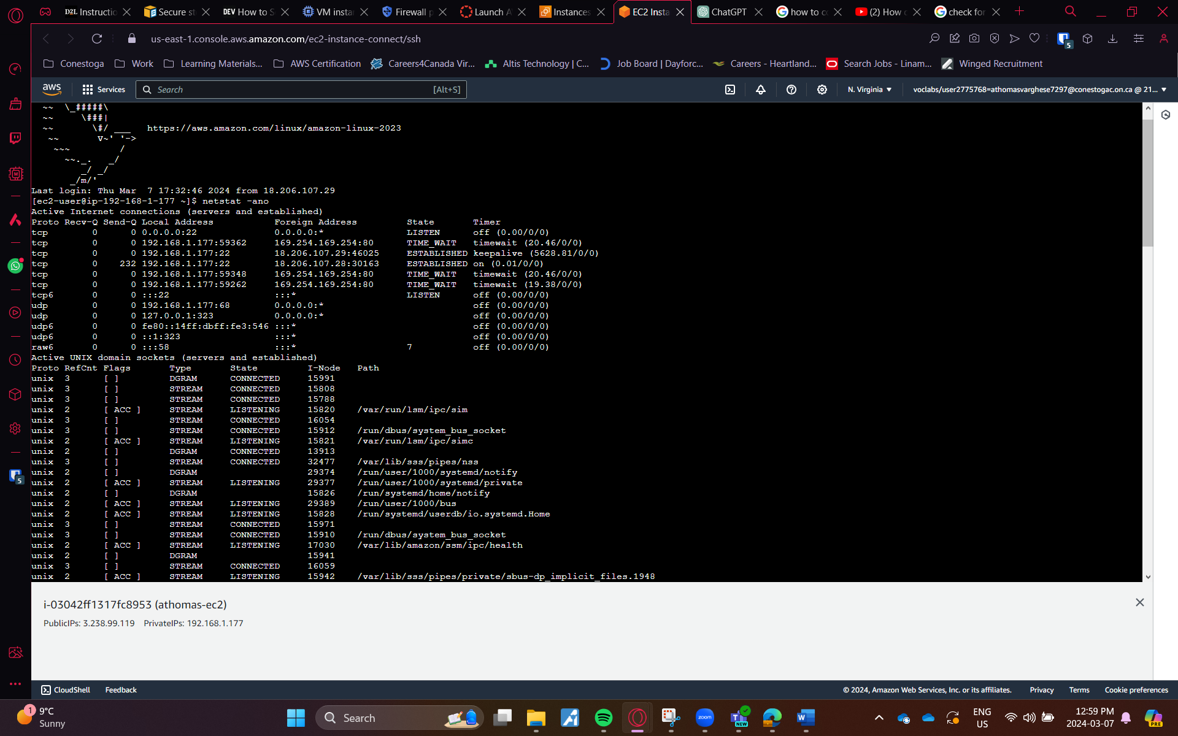Fig 23: Checking for open ports

For storage, enabling encryption is the best approach, upon creation of vm enabling encryption in storages can prevent the access of malicious actors to the volumes.  
  
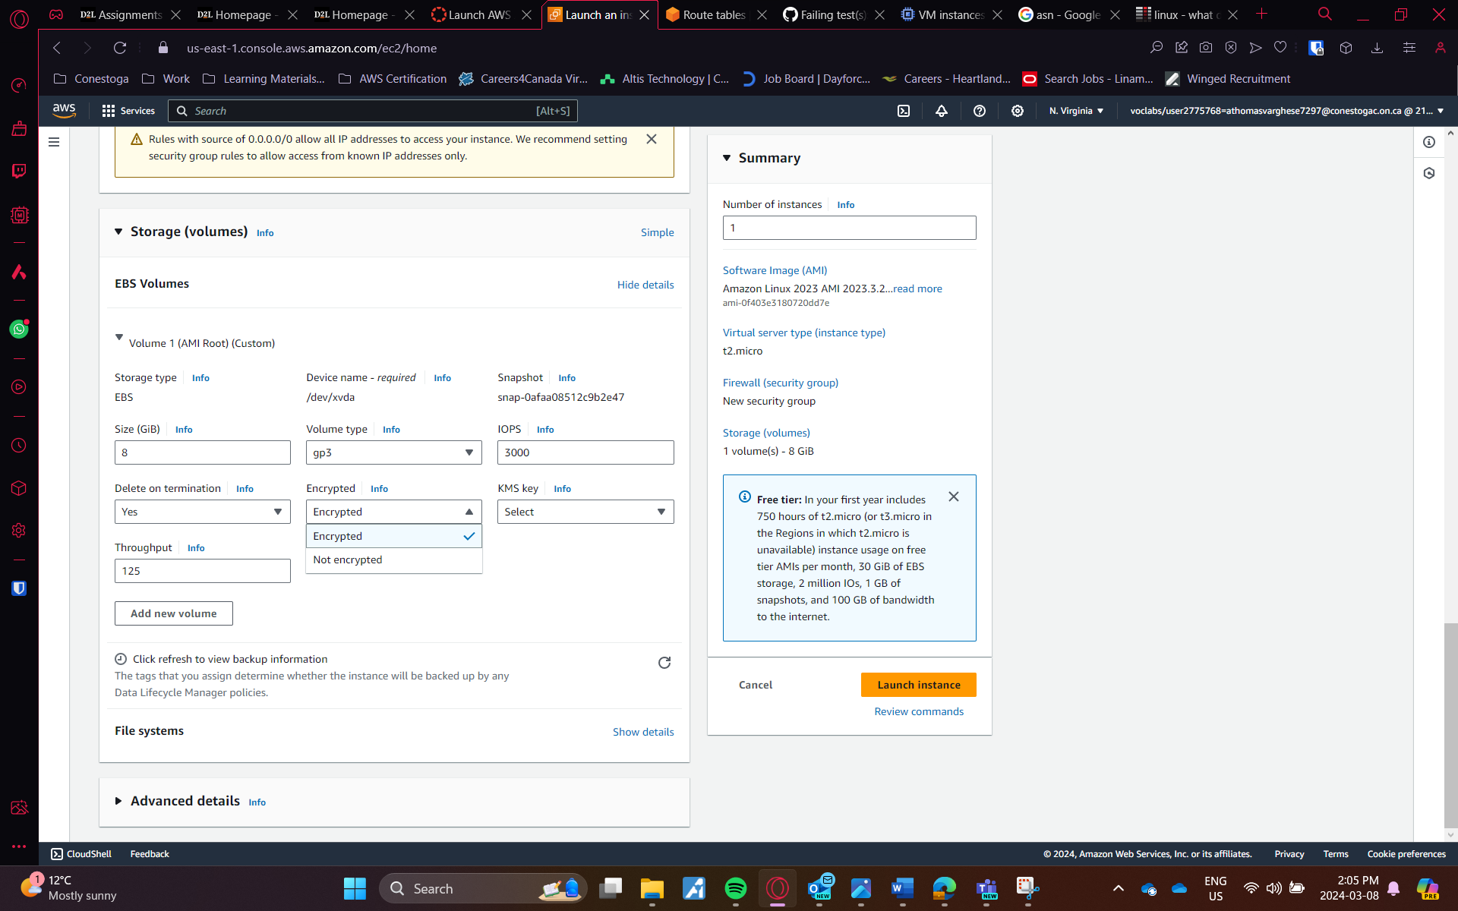 Fig 23: Enabling Encryption for EC2 Storage  
  
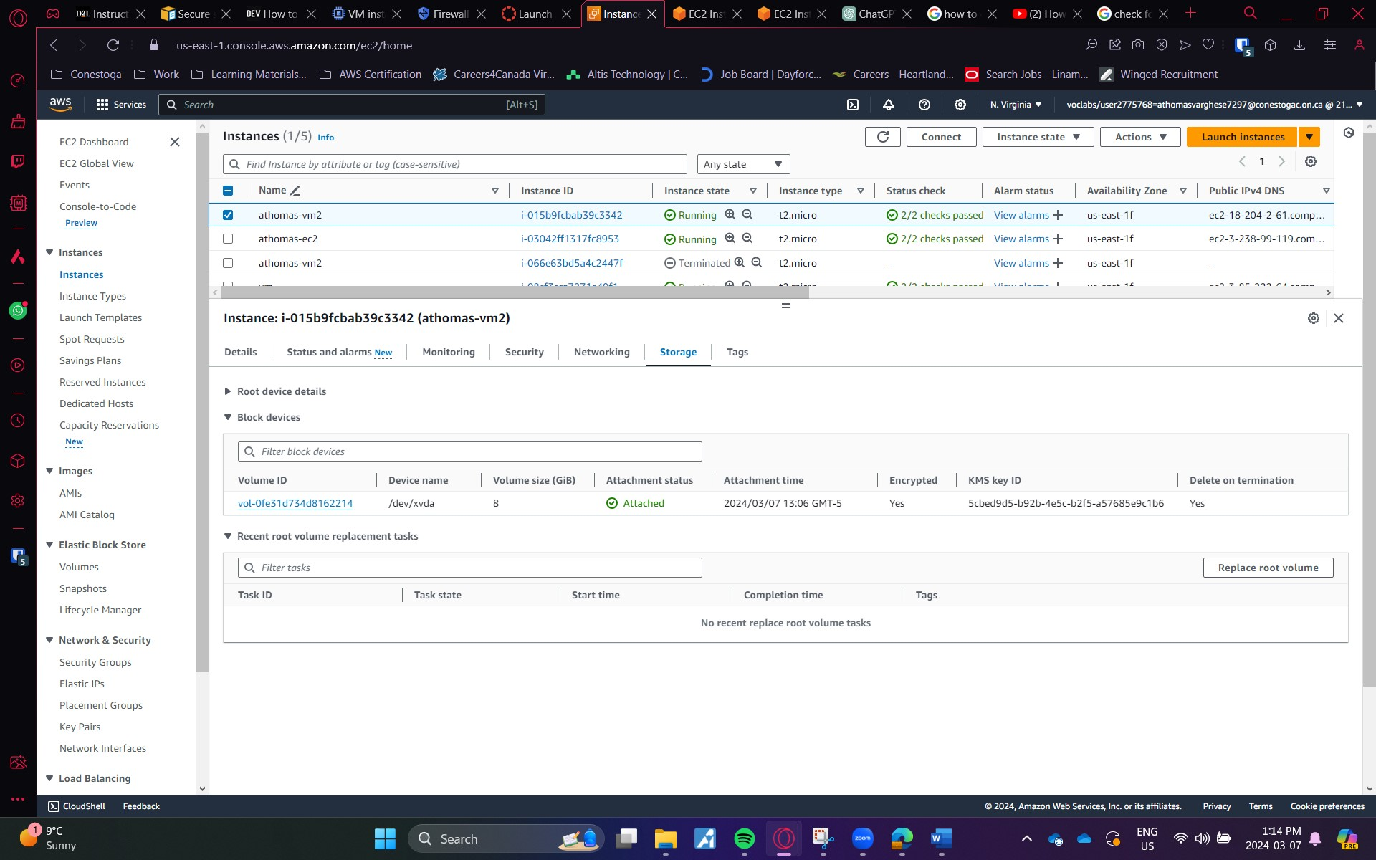 Fig 23: Encryption for EC2 Storage

## Reflection

The outcome of the lab was successful connection of the VPC networks using a high-availability site-to-site VPN with one end of the network connected to the public internet using internet gateway. The learning experience from this lab was great. As the classic VPN has its features deprecated, I had to find a new way of setting up the VPN in Google Cloud. Nevertheless, it showed me a new perspective of configuration. Even after setting up faced some challenges related to pinging, as the firewall rules on one side were blocking the request from the other side. The security of the infrastructure is important, so I learned the ways of how to secure it with the help of the internet and implemented a few measure in the lab.

## References

* Etuk, Mar 17, 2022)

How to Secure Amazon EC2 Instances

<https://dev.to/aws-builders/how-to-secure-amazon-ec2-instances-92b>

* (N. Sharma, Jun 19, 2023)

Site-To-Site IPSEC VPN Connectivity between Google Cloud and AWS

<https://medium.com/@nitinkrsharma/site-to-site-ipsec-vpn-connectivity-between-google-cloud-and-aws-c572b4dd893a>

* (VPC Network, Dec 29, 2019)

VPN between AWS & Google Gloud GCP

<https://www.youtube.com/watch?v=YBGD3gTVa2U>